IFT 166 Introduction to Internet Networking
Lab 15
Router Address Configuration

For all parts of the lab, assume all switches are layer 2 switches (unmanaged switches)
Part A: IP Configuration
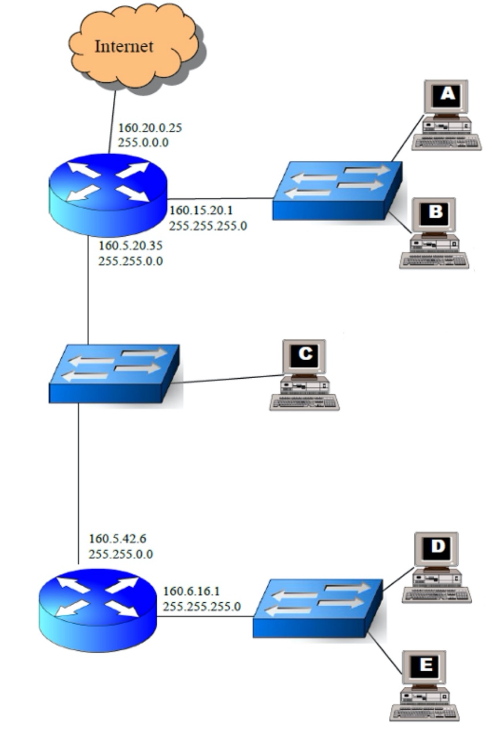
For each of the computers A, B, C, D and E assign an IP address, a subnet mask, and a default gateway.
By understanding the Router’s IP address and Subnet Mask, you should be able to configure the PCs on the networks. A PC can sometimes can get their configuration details from multiple routers.

IP Address | 160.15.20.2
Subnet Mask | 255.255.255.0
Default Gateway | 160.15.20.1

IP Address | 160.15.20.3
Subnet Mask | 255.255.255.0
Default Gateway | 160.15.20.1

IP Address | 160.5.20.36
Subnet Mask | 255.255.0.0
Default Gateway | 160.5.20.35

IP Address | 160.6.16.2
Subnet Mask | 255.255.255.0
Default Gateway | 160.6.16.1

IP Address | 160.6.16.3
Subnet Mask | 255.255.255.0
Default Gateway | 160.6.16.1

Assign an IP address, subnet mask, default gateway and DNS server address to Your PC in the following network:
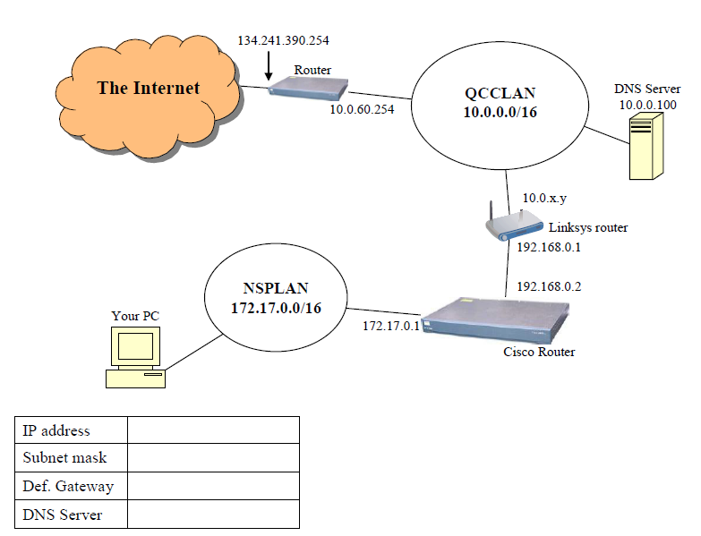

IP Address | 172.17.0.2
Subnet Mask | 255.255.255.0
Default Gateway | 172.17.0.1
DNS Address | 10.0.0.100

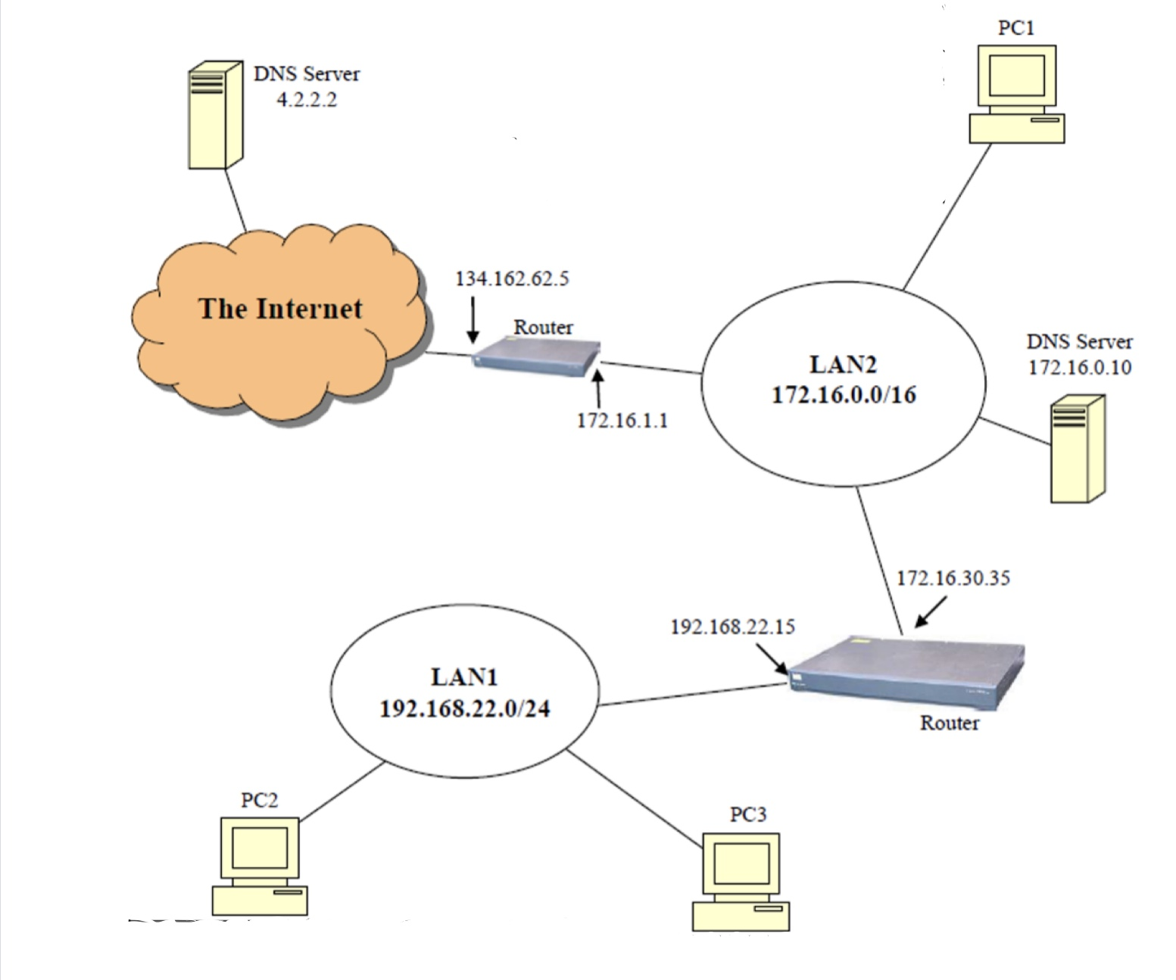
Assign a valid IP address, SM, DG, and DNS server address to PC1, PC2, and PC3 in the following network:
IP Address | Enter
Subnet Mask | Enter
Default Gateway | Enter
DNS Address | Enter

IP Address | Enter
Subnet Mask | Enter
Default Gateway | Enter
DNS Address | Enter

IP Address | Enter
Subnet Mask | Enter
Default Gateway | Enter
DNS Address | Enter

For each of the computers A, B, and C, assign an IP address, a subnet mask, and a default gateway.
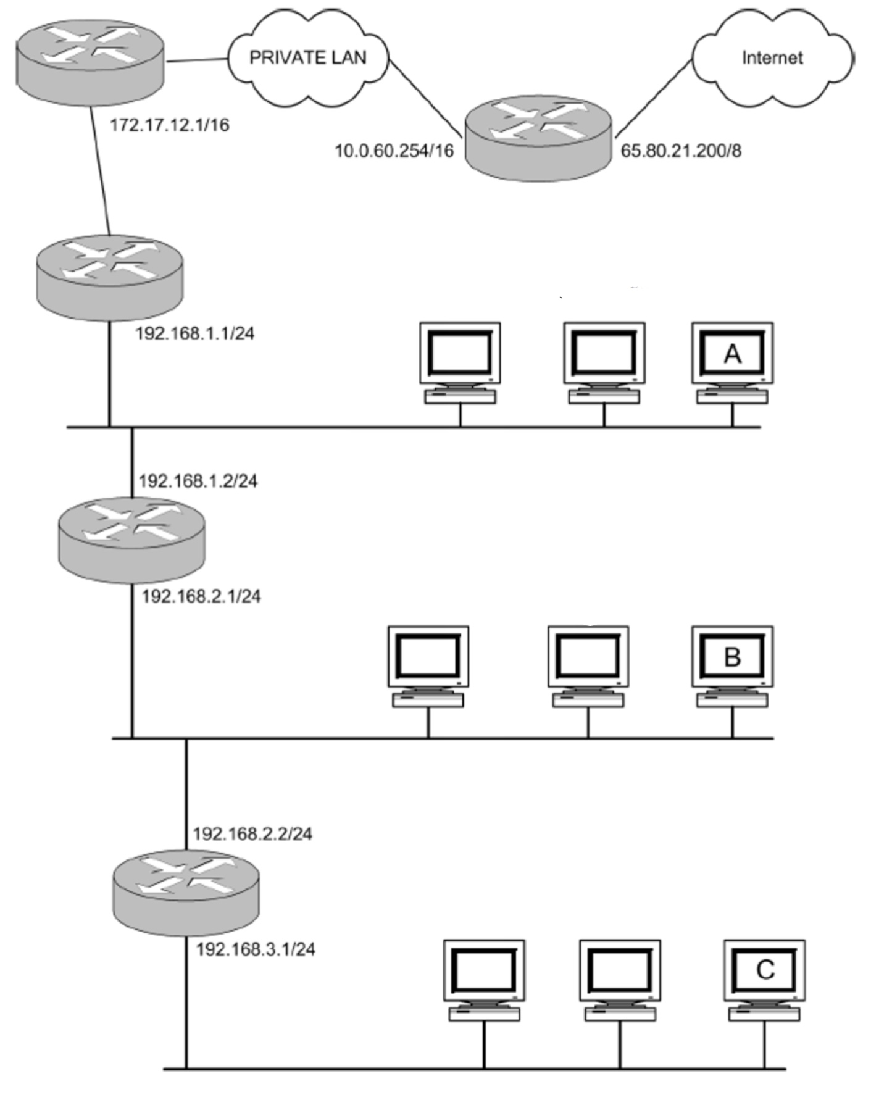

IP Address | Enter
Subnet Mask | Enter
Default Gateway | Enter

IP Address | Enter
Subnet Mask | Enter
Default Gateway | Enter

IP Address | Enter
Subnet Mask | Enter
Default Gateway | Enter

For each of the computers A, B, and C, assign an IP address, a subnet mask, and a default gateway.
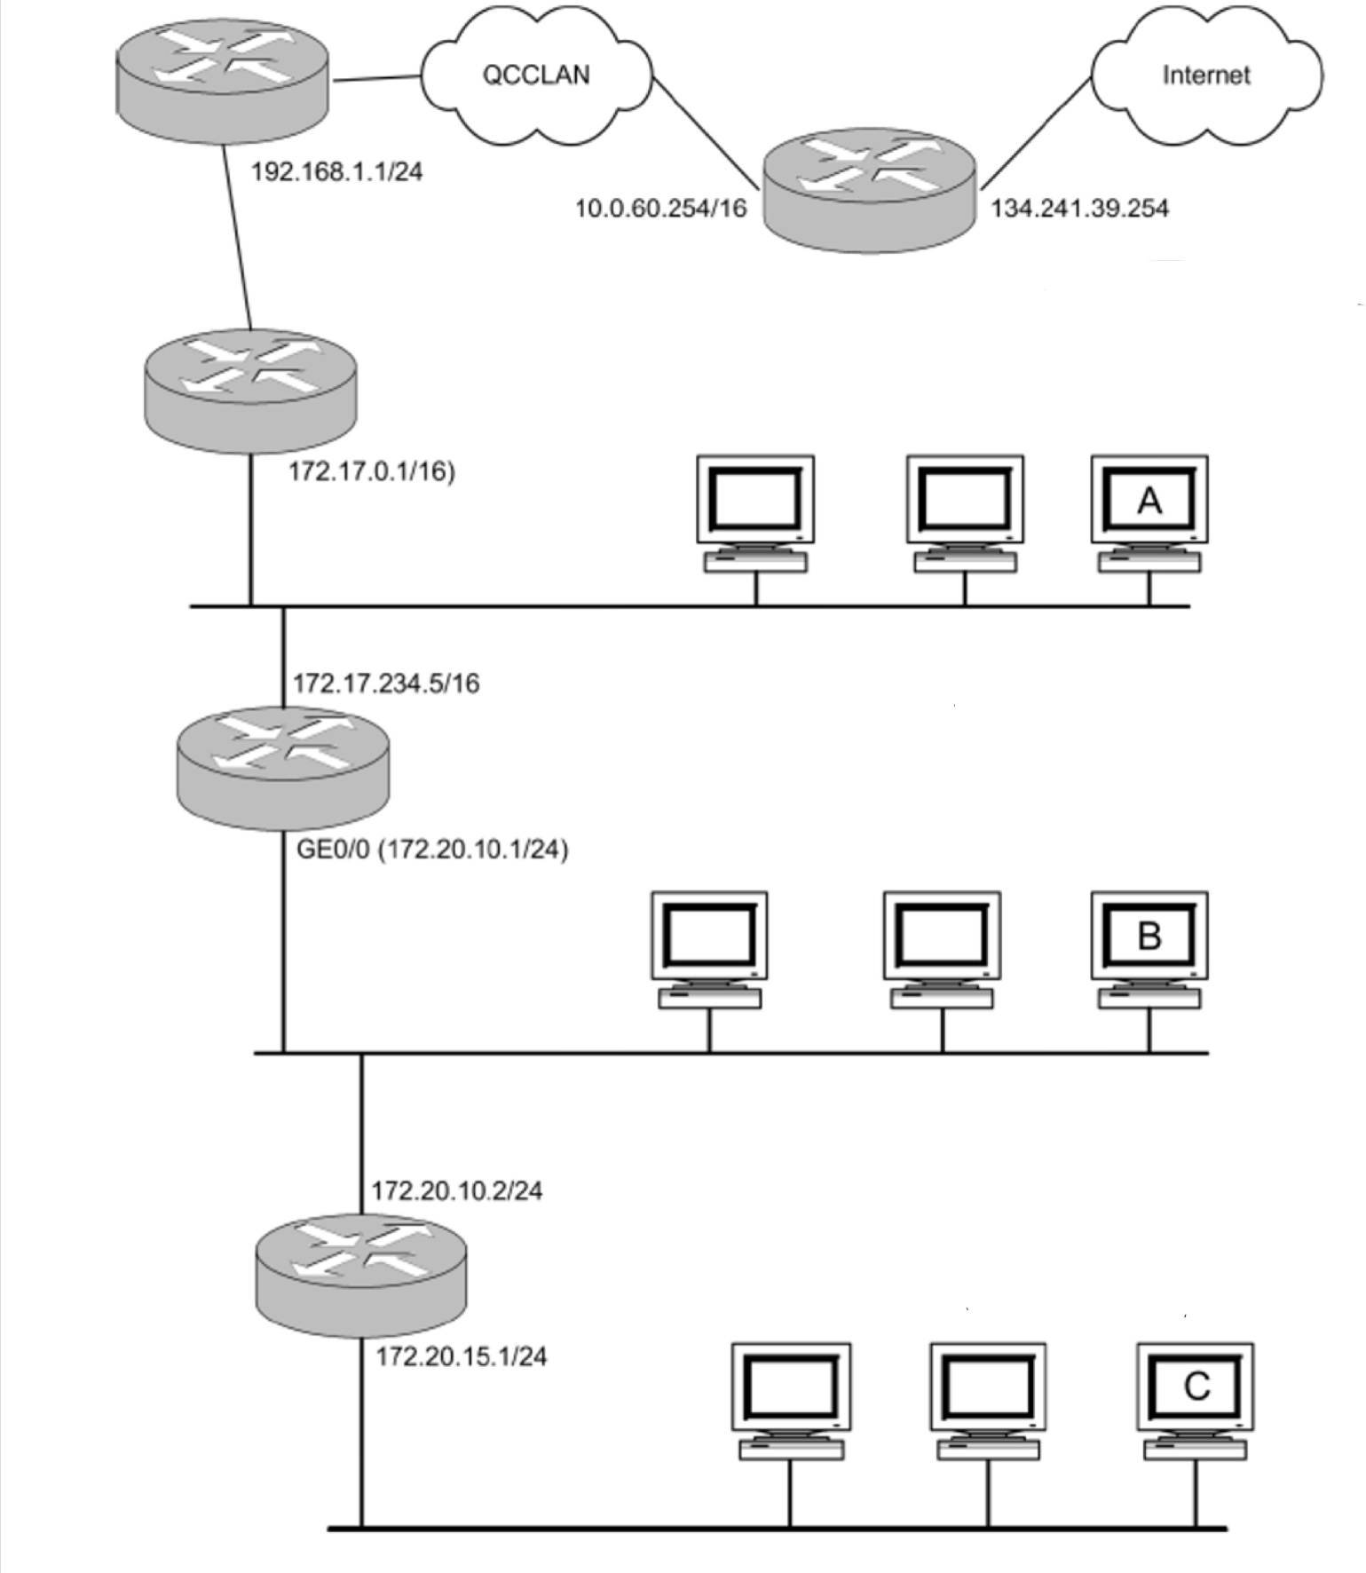

IP Address | Enter
Subnet Mask | Enter
Default Gateway | Enter

IP Address | Enter
Subnet Mask | Enter
Default Gateway | Enter

IP Address | Enter
Subnet Mask | Enter
Default Gateway | Enter

For each of the computers A, B, C, D, and E assign an IP address, a subnet mask, and a default gateway.
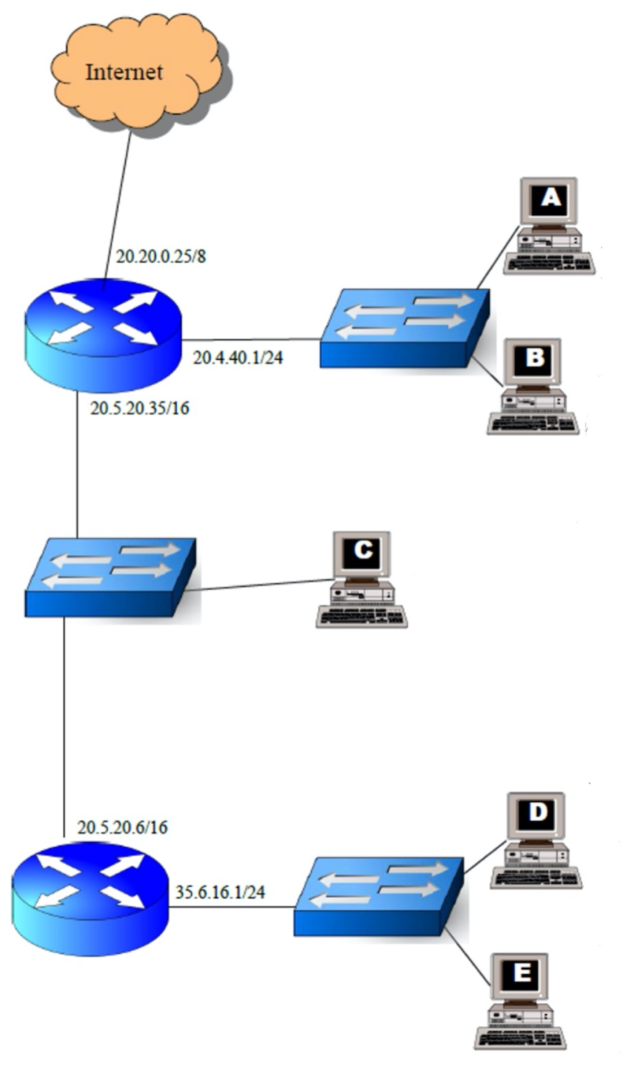

IP Address | Enter
Subnet Mask | Enter
Default Gateway | Enter

IP Address | Enter
Subnet Mask | Enter
Default Gateway | Enter

IP Address | Enter
Subnet Mask | Enter
Default Gateway | Enter

IP Address | Enter
Subnet Mask | Enter
Default Gateway | Enter

IP Address | Enter
Subnet Mask | Enter
Default Gateway | Enter

